Michael Potter

ENGR131A-80

UID 705644667

Final Project (**based on first Class Project upload**)

1.

a.

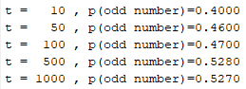

b.

$$S_{x}=\left\{1,2,3,4\right\} \\ P\left(X is odd\right)=P\left\{X=1 or X=3\right\}=\frac{1}{2}$$

c. The experimental result approaches the theoretical result as the number of coin tosses increases (and they are approximately equal as t goes to infinity due to law of large numbers).

d.

$$x+y=1 \\ x=2y \\ 2y+y=1 \\ y=\frac{1}{3};x=\frac{2}{3} \\ P\left(odd\right)=\frac{1}{3} ;P\left(even\right)=\frac{2}{3}$$

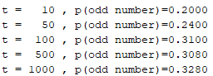

Similarly to part c, the experimental result approaches the theoretical result as the number of coin tosses increases (and they are approximately equal as t goes to infinity due to law of large numbers).

2.

a.

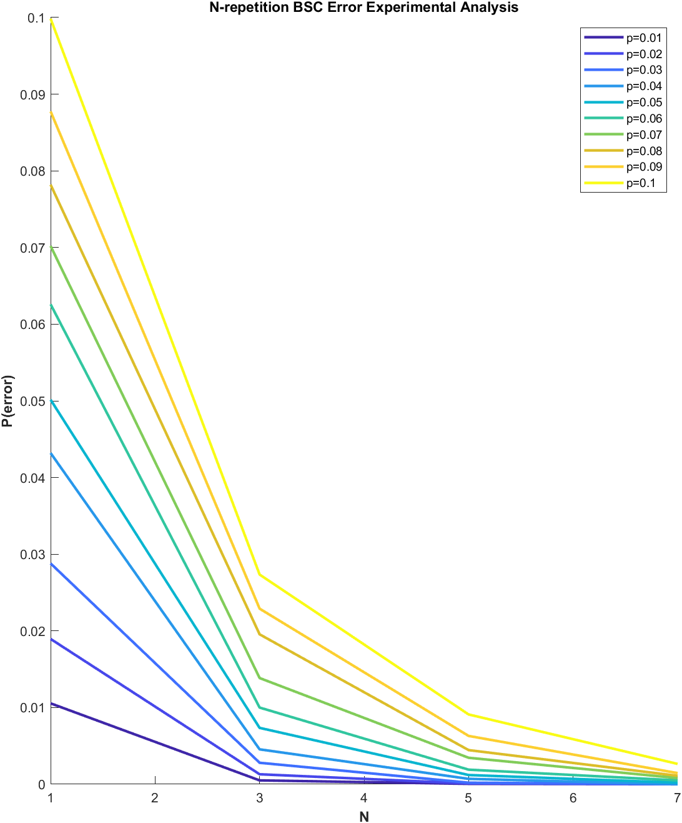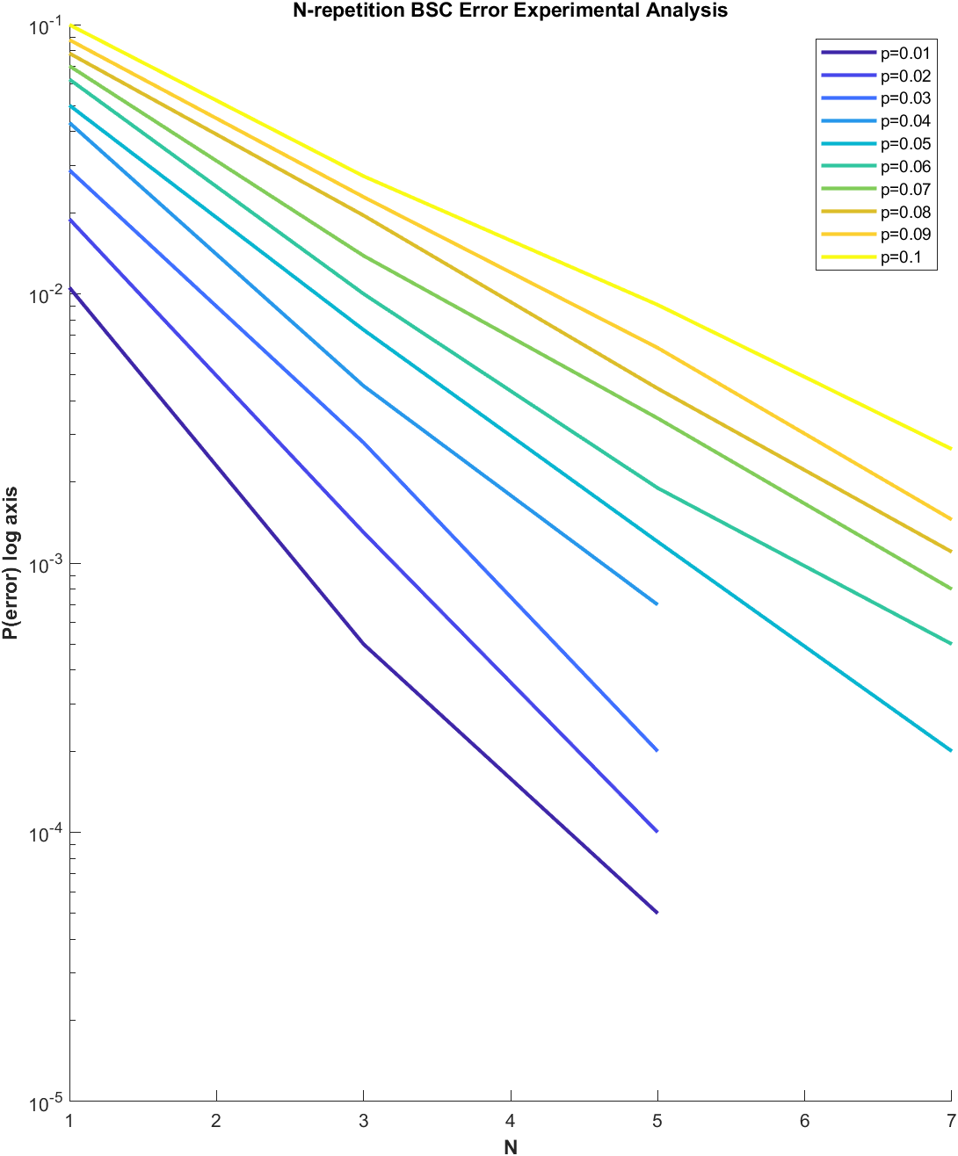

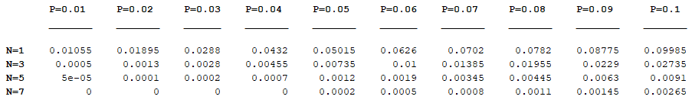

b.

$$N=1,3,5,7,…odd number \\ n=\left\lceil \frac{N}{2}\right\rceil ;p\left(bit=0\right)=\frac{1}{2} ;p\left(bit=1\right)=\frac{1}{2} \\ p\left(error | bit=0\right)=\sum_{i=n}^{N}{\left(\begin{matrix}N \\ i\end{matrix}\right){\left(1-p\right)}^{N-i}p^{i}} \\ p\left(error | bit=1\right)=\sum_{i=n}^{N}{\left(\begin{matrix}N \\ i\end{matrix}\right){\left(1-p\right)}^{N-i}p^{i}} \\ p\left(error\right)=p\left(bit=0\right)*p\left(error \right| bit=0)+p(bit=1)*p(error \left| bit=1\right) \\ = \sum_{i=n}^{N}{\left(\begin{matrix}N \\ i\end{matrix}\right){\left(1-p\right)}^{N-i}p^{i}}$$

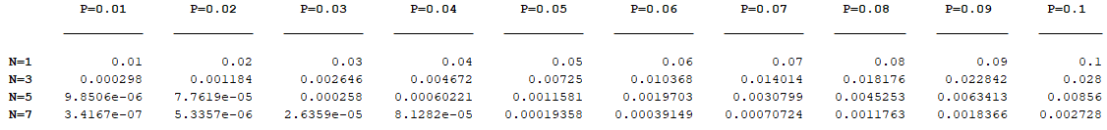

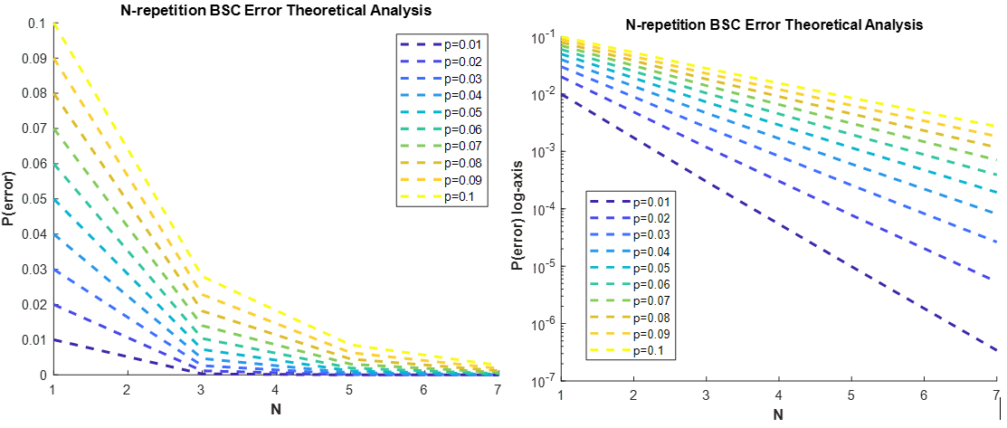

c. If the BSC channel has the probability of flipping a bit equal to 0.5, then the BSC channel is uninterpretable (a random channel), as the user cannot determine what bit was sent. To show this, follow the proof below:

$$N=1,3,5,7,…odd number \\ n=\left\lceil \frac{N}{2}\right\rceil ;p\left(bit sent=0\right)=\frac{1}{2} ; p\left(bit sent=1\right)=\frac{1}{2}; \\ p\left(bit 1 flipped\right)=\frac{1}{2} ; p\left(bit 0 flipped\right)=\frac{1}{2}; \\ 1-p\left(bit 1 flipped\right)=\frac{1}{2}=p\left(bit 1 flipped\right); 1-p\left(bit 0 flipped\right)=\frac{1}{2}=p(bit 0 flipped) \\ receive=R, sent=S$$

$$p\left(R= 0 | S=0\right)=\sum_{i=n}^{N}{\left(\begin{matrix}N \\ i\end{matrix}\right){{\left(p\left(bit 0 flipped\right)\right)}^{N-i }\left(1-p\left(bit 0 flipped\right)\right)}^{i}} =\sum_{i=n}^{N}{\left(\begin{matrix}N \\ i\end{matrix}\right){{\left(1-p\left(bit 0 flipped\right)\right)}^{N-i }\left(p\left(bit 0 flipped\right)\right)}^{i}}=p\left(R=1 \right|S=0)$$

Then, by the same logic as the derivation above, p(R=1 | S=1) = p(R=0 | S=1)

$$p\left(R=0 \right|S=0)=P\left(R=0 \right| S=1)=P\left(R=1 \right|S=0)=P\left(R=1 \right| S=1)$$

$$P\left(S=1\right)=P(S=0)$$

$$p\left(S=1 \right|R= 0)=\frac{p\left(R=0 \right|S=1)*p\left(S=1\right) }{\sum_{i=\left\{0,1\right\}}{P\left(R=0 \right|S=i)*P(S=i)}} = \frac{p\left(R=0 \right|S=0)*p\left(S=0\right) }{\sum_{i=\left\{0,1\right\}}{P\left(R=0 \right|S=i)*P(S=i)}}=P\left(S=0 \right|R=0)$$ and the same logic holds for p(S=0 | R = 1) = p(S=1 | R=1).

If I knew that 0.5 < p < 1 then I would say that the receiver should swap the 1s with the 0s and vice versa to get an equivalent channel cross probability of (1-p) < ½ .

3.

a.

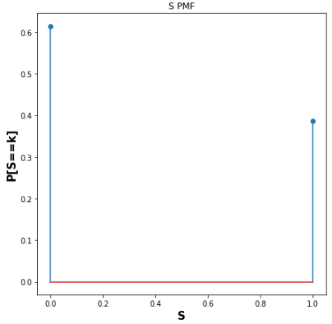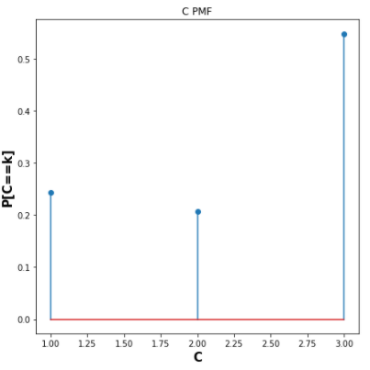

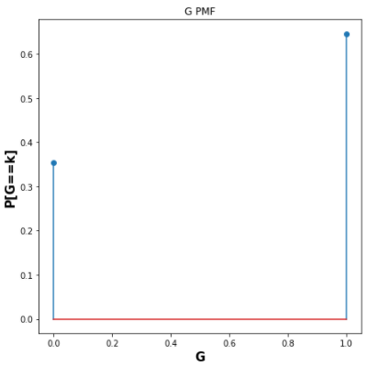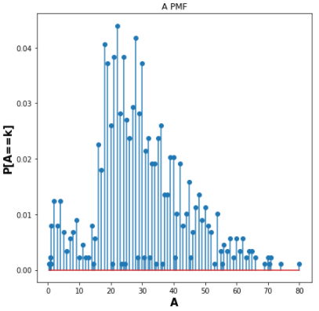

b.

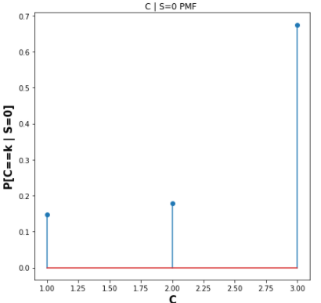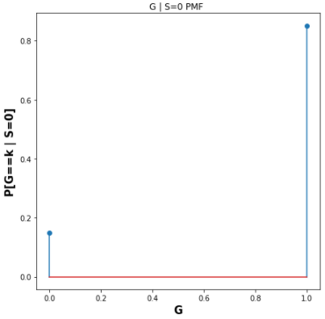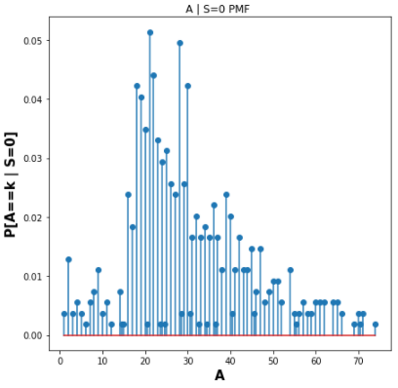

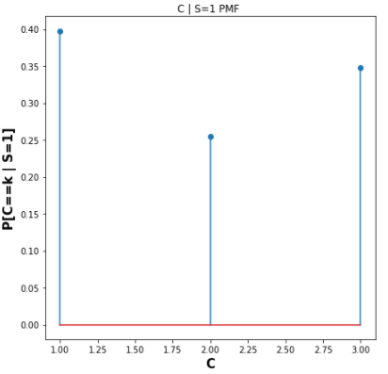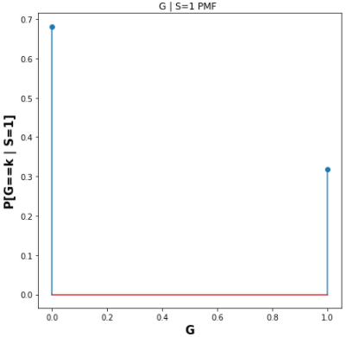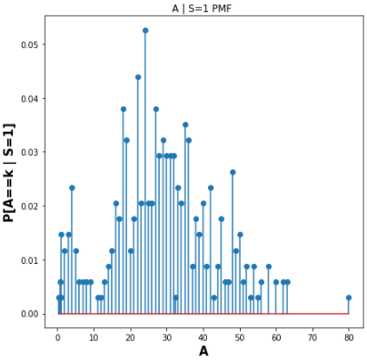

c.

$$P\left(S=0,C=1,G=0,A≤40\right)=P\left(C=1,G=0,A≤40 | S=0\right)*P\left(S=0\right) \\ = P\left(C=1 \right| S=0) P\left(G=0 \right|S=0) P\left(A≤40 \right|S=0) P(S=0)$$ $=$**0.010625322687488965**

$$P\left(S=1,C=1,G=0,A≤40\right)=P\left(C=1,G=0,A≤40 | S=1\right)*P\left(S=1\right) \\ = P\left(C=1 \right| S=1) P\left(G=0 \right|S=1) P\left(A≤40 \right|S=1) P(S=1)$$ $=$**0.08460553314142813**

d.

$$P\left(S=0 \right|C=1, G=0, A≤40)= \frac{P\left(C=1,G=0,A≤40 \right|S=0) P(S=0)}{P\left(C=1,G=0,A≤40\right)} \\ =\frac{P\left(C=1,G=0,A≤40 \right|S=0) P(S=0)}{\sum_{i=\left\{0,1\right\}}{P\left(C=1,G=0,A≤40,S=i\right)}} \\ = \frac{P\left(C=1,G=0,A≤40 \right|S=0) P(S=0)}{P\left(C=1,G=0,A≤40 \right|S=1) P\left(S=1\right)+ P\left(C=1,G=0,A≤40 \right|S=0) P(S=0)}$$ $=$**0.11157436941003064**

$$P\left(S=1 \right|C=1, G=0, A≤40)= \frac{P\left(C=1,G=0,A≤40 \right|S=1) P(S=1)}{P\left(C=1,G=0,A≤40\right)} \\ =\frac{P\left(C=1,G=0,A≤40 \right|S=1) P(S=1)}{\sum_{i=\left\{0,1\right\}}{P\left(C=1,G=0,A≤40,S=i\right)}} \\ = \frac{P\left(C=1,G=0,A≤40 \right|S=1) P(S=1)}{P\left(C=1,G=0,A≤40 \right|S=1) P\left(S=1\right)+ P\left(C=1,G=0,A≤40 \right|S=0) P(S=0)}$$ $=$**0.8884256305899694**

She will survive with probability of approximately 0.888 (most likely will survive…) .

4.

a.

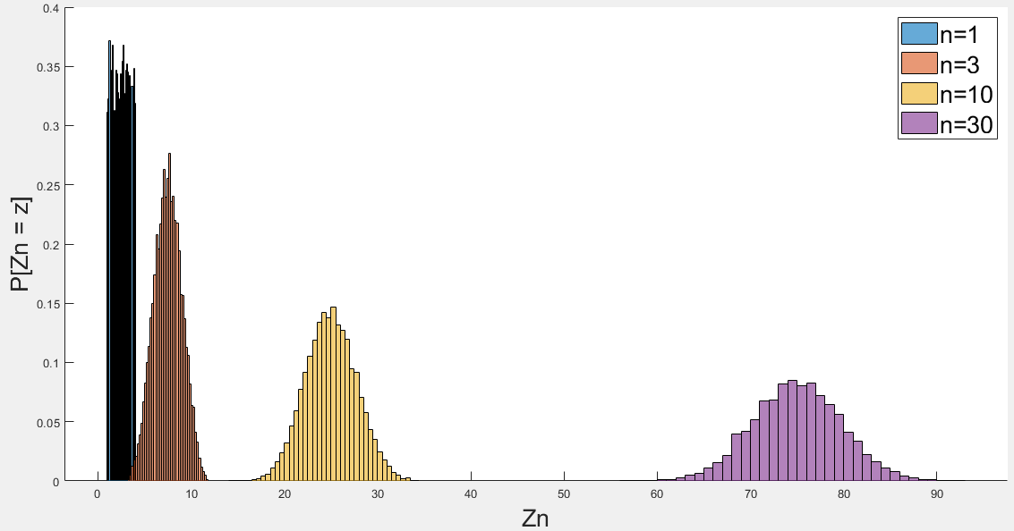

As n increases (and approaches infinity) the distribution of $Z_{n}$ becomes a Gaussian distribution. This is evident by looking at the difference between n = 1, and n = 30. At n = 1, the distribution of appears to still be a uniform distribution like the iid , but when n = 30, the distribution of $Z_{n}$ appears to be a Gaussian distribution. The tails become wider and wider as n increases, with the peak probability at the mean decreasing.

b.

$$E\left[X_{i}\right]=\frac{\left(a+b\right)}{2}=\frac{5}{2}; Var\left(X_{i}\right)=\frac{{\left(b-a\right)}^{2}}{12}=\frac{3}{4} \\ E\left[Z_{n}\right]=n*E\left[X_{i}\right]=\frac{5n}{2} ;Var\left(Z_{n}\right)=\frac{n*{\left(b-a\right)}^{2}}{12}=\frac{3n}{4}$$

|  |  |  |
| --- | --- | --- |
| **n** | **E[Zn]** | **Var(Zn)** |
| 1 | 2.5 | 0.75 |
| 3 | 7.5 | 2.25 |
| 10 | 25.0 | 7.50 |
| 30 | 75.0 | 22.5 |

c.

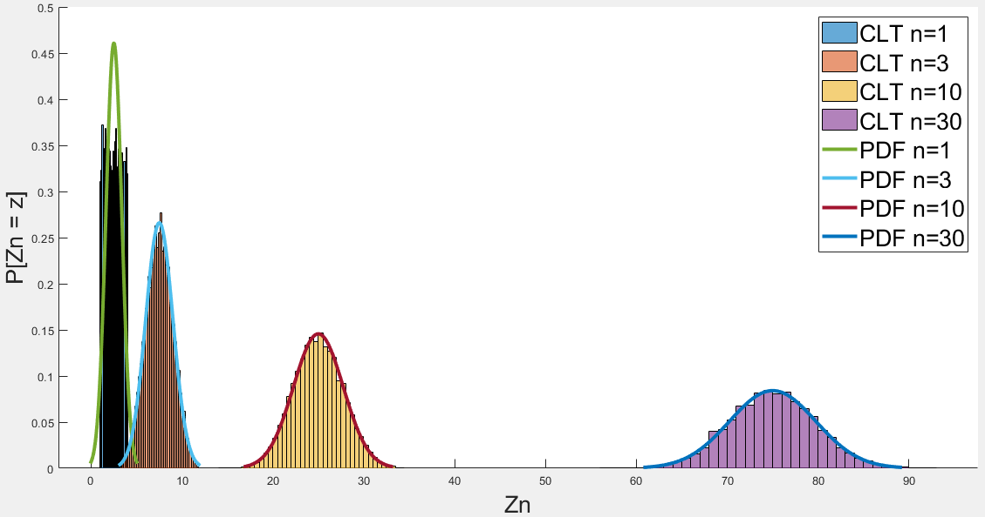

d.

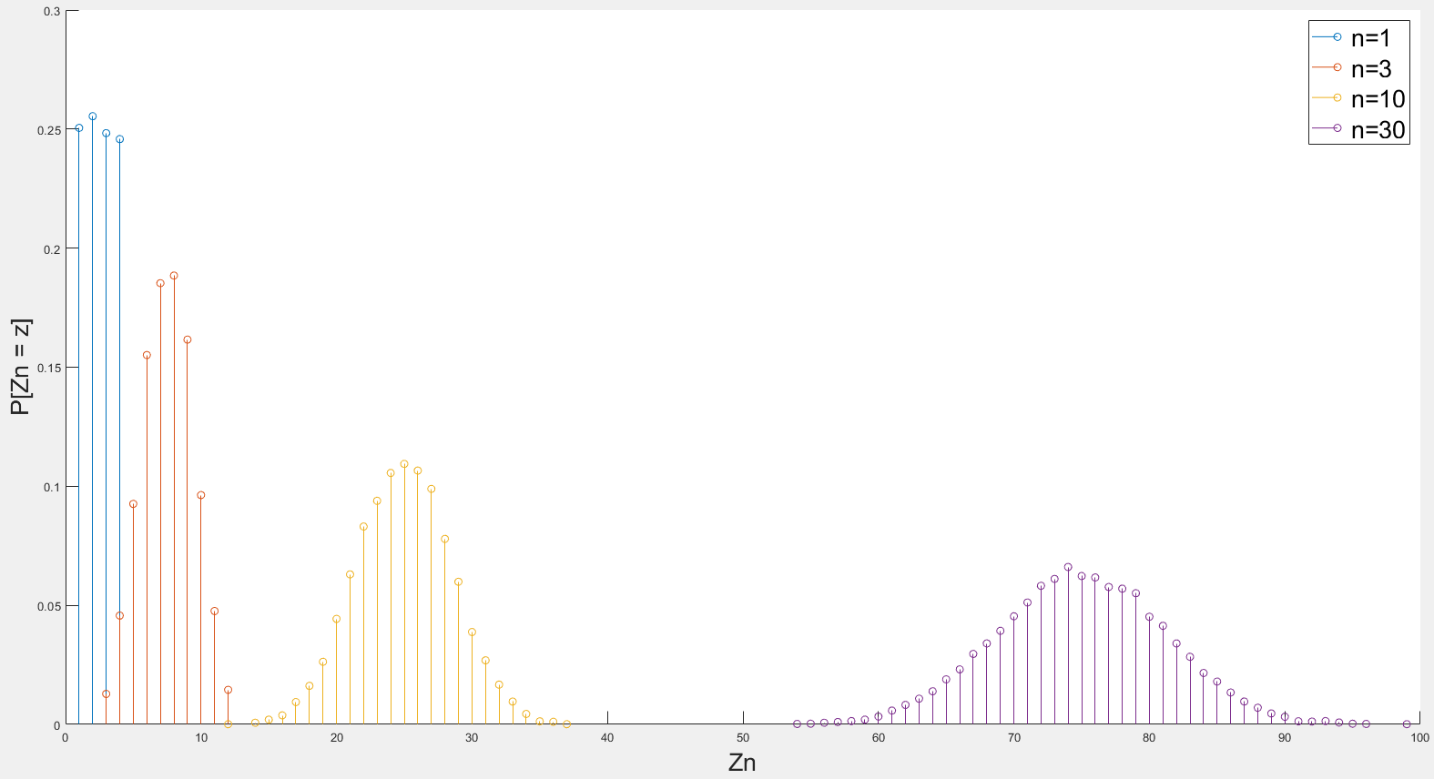

As n increases (and approaches infinity) the distribution of $Z_{n}$ becomes a Gaussian distribution. This is evident by looking at the difference between n = 1, and n = 30. At n = 1, the distribution of appears to still be a uniform distribution like the iid , but when n = 30, the distribution of $Z_{n}$ appears to be a Gaussian distribution. The tails become wider and wider as n increases, with the peak decreasing. A difference between part (a) is that Zn is discrete random variable.

$$E\left[X_{i}\right]=\frac{\left(a+b\right)}{2}=\frac{5}{2};Var\left(X_{i}\right)=\frac{{\left(b-a+1\right)}^{2}-1}{12}=\frac{15}{12} \\ E\left[Z_{n}\right]=n*E\left[X_{i}\right]=\frac{5n}{2} ;Var\left(Z_{n}\right)=\frac{n*[{\left(b-a+1\right)}^{2}-1]}{12}=\frac{15n}{12}$$

|  |  |  |
| --- | --- | --- |
| **n** | **E[Zn]** | **Var(Zn)** |
| 1 | 2.5 | 1.25 |
| 3 | 7.5 | 3.75 |
| 10 | 25.0 | 12.5 |
| 30 | 75.0 | 37.5 |

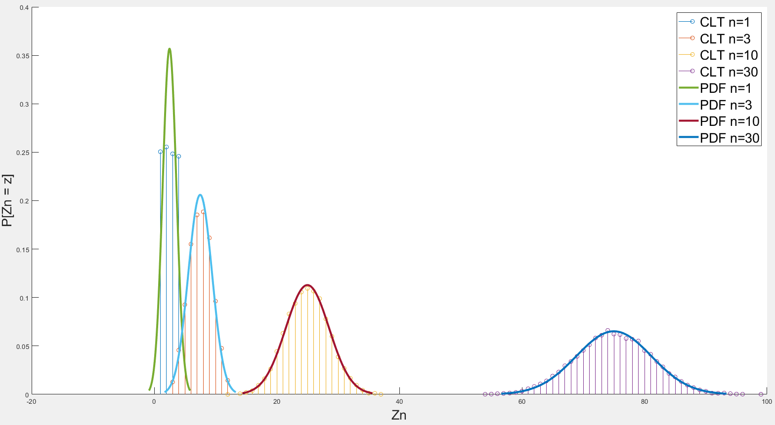

Appendix (Code)

**1.**

%% 1a

close all; clear all; clc;

tosses = [10,50,100,500,1000];

for t = tosses

p_odd = mean(mod(randi(4,1,t),2));

fprintf("t =%5d , p(odd number)=%.4f\n",t,p_odd)

end

%% 1d

close all; clear all; clc;

tosses = [10,50,100,500,1000];

s = RandStream('mlfg6331_64');

for t = tosses

p_odd = mean(mod(datasample(s,1:4,t,'Weights',[1/6,2/6,1/6,2/6]),2));

fprintf("t =%5d , p(odd number)=%.4f\n",t,p_odd)

end

**2.**

close all; clear all; clc;

%%

p = 0.01:0.01:.1;

N = 1:2:7;

for i = 1:length(N)

for j = 1:length(p)

[bits_sent,bits_encoded] = transmitted(p(j),N(i));

p_error(i,j) = mean(decoder(bits_sent,N(i)) ~= bits_encoded);

theoretical_error(i,j) = p_error_theor(p(j),N(i));

end

end

subplot(1,2,1)

hold on

cmap = colormap(parula(length(p)));

for i = 1:length(p)

plot(N,p_error(:,i),'Color',cmap(i,:),'LineWidth',2)

end

legend("p="+string(p))

title("N-repetition BSC Error Experimental Analysis")

xlabel("N",'FontWeight','bold')

ylabel("P(error)",'FontWeight','bold')

figure(1)

subplot(1,2,2)

hold on

cmap = colormap(parula(length(p)));

for i = 1:length(p)

plot(N,p_error(:,i),'Color',cmap(i,:),'LineWidth',2)

end

set(gca,'yscale','log')

legend("p="+string(p))

title("N-repetition BSC Error Experimental Analysis")

xlabel("N",'FontWeight','bold')

ylabel("P(error) log axis",'FontWeight','bold')

array2table(p_error,'RowNames',"N="+string(N),'VariableNames',"P="+string(p))

%%

figure(2)

subplot(1,2,2)

hold on

for i = 1:length(p)

plot(N,theoretical_error(:,i),'Color',cmap(i,:),'LineStyle','--','LineWidth',2)

end

legend("p="+string(p))

set(gca,'yscale','log')

legend("p="+string(p))

title("N-repetition BSC Error Theoretical Analysis")

xlabel("N",'FontWeight','bold')

ylabel("P(error) log axis",'FontWeight','bold')

subplot(1,2,1)

hold on

for i = 1:length(p)

plot(N,theoretical_error(:,i),'Color',cmap(i,:),'LineStyle','--','LineWidth',2)

end

legend("p="+string(p))

legend("p="+string(p))

title("N-repetition BSC Error Theoretical Analysis")

xlabel("N",'FontWeight','bold')

ylabel("P(error)",'FontWeight','bold')

array2table(theoretical_error,'RowNames',"N="+string(N),'VariableNames',"P="+string(p))

%%

function [bits_sent,bits_encoded] = transmitted(p,N)

bits_encoded = rand(20000,1) < .5; % <.5 is 1, >= .5 is 0 transmitted

bits_sent = rand(20000,N);

bits_sent = (bits_sent < p) .* (1-bits_encoded) + (1-(bits_sent < p)) .* bits_encoded;

end

function bits_received = decoder(transmission,N)

bits_received = sum(transmission,2)>N/2;

end

function theoretical_error = p_error_theor(p,N)

n = ceil(N/2);

theoretical_error = 0;

for i = n:N

theoretical_error = theoretical_error + nchoosek(N,i)*p^i*(1-p)^(N-i);

end

end

**3. (in python)**

import pandas as pd

import numpy as np

import matplotlib.pyplot as plt

import os

titanic = pd.read_csv("titanic.csv").rename(columns={'Survived':'S','Pclass':'C','Sex':'G','Age':'A'})

titanic.head()

titanic.describe()

titanic.isna().sum()

# a

N = titanic.shape[0]

PMF = {}

for col in titanic.columns:

plt.figure(figsize=(7,7))

ps = titanic[col].value_counts()/N

plt.stem(ps.index,ps)

plt.title("{} PMF".format(col))

plt.xlabel(col,fontsize=15,weight='bold')

plt.ylabel("P[{}==k]".format(col),fontsize=15,weight='bold')

PMF[col] = ps

# b

survived = titanic.pop("S")

survived.unique()

PMF_Conditioned = {}

for survival in survived.unique():

for col in titanic.columns:

plt.figure(figsize=(7,7))

N = (survived==survival).sum()

ps = (titanic[col][survived==survival]).value_counts() / N

plt.stem(ps.index,ps)

plt.title("{} | S={} PMF ".format(col,survival))

plt.xlabel(col,fontsize=15,weight='bold')

plt.ylabel("P[{}==k | S={}]".format(col,survival),fontsize=15,weight='bold')

PMF_Conditioned["{}|S={}".format(col,survival)] = ps

# c

p0 = PMF['S'][0]*((PMF_Conditioned["A|S=0"][PMF_Conditioned["A|S=0"].index<=40]).sum())*(PMF_Conditioned["C|S=0"][1])*(PMF_Conditioned["G|S=0"][0])

p1 = PMF['S'][1]*((PMF_Conditioned["A|S=1"][PMF_Conditioned["A|S=1"].index<=40]).sum())*(PMF_Conditioned["C|S=1"][1])*(PMF_Conditioned["G|S=1"][0])

# d (she will survive)

p0 / (p0 + p1)

p1 / (p0 + p1)

**4.**

%% a

close all; clc; clear all;

samples = [1,3,10,30];

i = 1;

for n = samples

xs = rand(10000,n)*3 + 1;

Z = sum(xs,2);

fprintf("Z @ n =%3d = %4.5f ; =%4.5f\n",n,mean(Z),var(Z))

z(i,:) = Z;

i = i + 1;

end

figure(1)

hold on

for i = 1:length(samples)

histogram(z(i,:),'Normalization','pdf')

end

legend("n="+string(samples),'FontSize',20)

fprintf("\n\n")

ylabel("P[Zn = z]",'FontSize',20)

xlabel("Zn",'FontSize',20)

%% b

clearvars -except samples

i = 1;

for n = samples

mu = (4+1)/2;

var = (4-1)^2 / 12;

z_mu(i) = (mu*n);

z_var(i) = (var*n);

fprintf("Z_mu @ n = %3d = %4.5f\n",n,z_mu(i))

fprintf("Z_var @ n = %3d = %4.5f\n\n",n,z_var(i))

i = i + 1;

end

%% c

figure(1)

hold on

for i = 1:length(samples)

x = linspace(z_mu(i) - sqrt(z_var(i))*3,z_mu(i) + sqrt(z_var(i))*3,1000);

y = normpdf(x,z_mu(i),sqrt(z_var(i)));

plot(x,y,'linewidth',3)

end

legend('CLT n=1','CLT n=3','CLT n=10','CLT n=30','PDF n=1','PDF n=3','PDF n=10','PDF n=30')

%% a

close all; clc; clear all;

samples = [1,3,10,30];

i = 1;

for n = samples

xs = randi([1,4],10000,n);

Z = sum(xs,2);

fprintf("Z @ n =%3d = %4.5f ; =%4.5f\n",n,mean(Z),var(Z))

z(i,:) = Z;

i = i + 1;

end

%%

figure(1)

hold on

for i = 1:length(samples)

[C,ia,ic] = unique(z(i,:));

a_counts = accumarray(ic,1);

value_counts = [C', a_counts];

stem(C',a_counts/sum(a_counts));

end

legend("n="+string(samples),'FontSize',20)

fprintf("\n\n")

ylabel("P[Zn = z]",'FontSize',20)

xlabel("Zn",'FontSize',20)

%% b

clearvars -except samples

i = 1;

for n = samples

mu = (4+1)/2;

var = ((4-1+1)^2 - 1) / 12;

z_mu(i) = (mu*n);

z_var(i) = (var*n);

fprintf("Z_mu @ n = %3d = %4.5f\n",n,z_mu(i))

fprintf("Z_var @ n = %3d = %4.5f\n\n",n,z_var(i))

i = i + 1;

end

%% c

figure(1)

hold on

for i = 1:length(samples)

x = linspace(z_mu(i) - sqrt(z_var(i))*3,z_mu(i) + sqrt(z_var(i))*3,1000);

y = normpdf(x,z_mu(i),sqrt(z_var(i)));

plot(x,y,'linewidth',3)

end

legend('CLT n=1','CLT n=3','CLT n=10','CLT n=30','PDF n=1','PDF n=3','PDF n=10','PDF n=30')